

**Provisioning Template for Create/Modify Data Group**

**User Guide**

|  |  |  |
| --- | --- | --- |
| **Version** | **Remarks** | **Date** |
| **1.0** | **Provisioning Template User Guide for Create/Modify Data Group** | **28/07/2016** |
| **2.0** | **Updated document with installation of the template.** | **14/02/2017** |
|  |  |  |
|  |  |  |

## Installation of the Template and Helper Script

1. Login to AppViewX.
2. On the left navigation menu, select ***Provisioning***; and click ***Template.***
3. On the upper right portion of the screen click on the  Import button.
4. The following screen will appear. 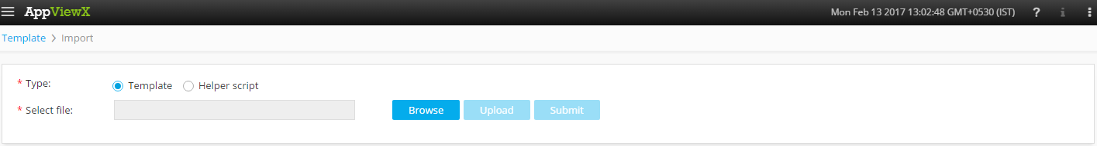
5. Please Select Template/Helper Script.  
   If Template is chosen,
   1. Click on *Browse* and select the Zip File of the template which has to be installed/imported and click open.
   2. Click on upload to import the Zip file and display the templates present in the zip file.
   3. Click on submit to deploy the templates into the AppViewX Environment.

If Helper Script is chosen,

1. Click on *Browse* and select the Zip File of the Helper script which has to be installed/imported and click open.
2. Click on upload to import the Zip file and display the Helper Scripts present in the zip file.
3. Click on submit to deploy the Helper Scripts into the AppViewX Environment.

## Create/Modify Data Group

1. Login to AppViewX.
2. On the left navigation menu, select ***Provisioning***; and click ***Request***
3. On the upper right portion of the screen, click the  ***Create*** button.
4. Select the provisioning template name from the list – ‘**Generic**_**Create_Modify_DataGroup**’

**Note:** *If no template is available, this indicates that the user role does not have permission to the requesting template.*

1. Enter the provisioning request description – ‘*Create or Modify Data Group on F5 device*’.
2. Add a default Request scenario name relevant to the template. ***E.g***.: VIP creation on F5/Citrix ADC.
3. Click on ‘**Fetch Device List’** button to populate the list of available F5 devices from the inventory.
4. Select the F5 device from the available list of device in the **Select Device** field.
5. Choose the operation to be performed on the selected F5 device in the **Data Group** field. ‘*Create new’* and ‘*Modify’* are the available operations.

If **Create New** is selected, then

* 1. Please input the name of the DataGroup to be created in the **Enter the Data Group Name** field.
  2. The DataGroup type can be selected from the **Select Type** field. The available DataGroup types would be *Integer, Address* and *String.*
  3. The appropriate *Key (String, Address* or *Integer)* and corresponding *Value* are entered in the next 2 fields.
  4. The Data Group entry can be added into the tabular for creation of Data Group on the selected device by clicking on the.
  5. Click  Button; ensure that the Scenario is displayed on the right hand pane.
  6. Click on *Submit* to generate work order(s) for the provisioning request.

If **Modify** is selected, then

1. Click on ‘***Fetch Data Group***’ button to fetch the list of available Data Groups on the selected device.
2. In the **Select Data Group** field, list of data groups are populated based on the *device* selected. Please select the data group to be modified.
3. The **Get Data Group Type** button can be used to check the type of the selected data group.
4. If data group members are to be deleted, click *Yes* in the **Do you want to delete members in Data Group** field.
5. The **Get Member List** button fetched the list of members in the selected data group.
6. Please select the member to be deleted from the dropdown list and add appropriate *Comments* in the **Comments** field.
7. *Member* to be deleted can be added to the tabular by clicking on the.
8. If data group members are to be added, click *Yes* in the **Do you want to add members in Data Group** field.
9. Please enter the *Data Group member name* and the appropriate *value.*
10. *Member* to be added can be appended to the tabular by clicking on the.
    1. Click  Button; ensure that the Scenario is displayed on the right hand pane.
    2. Click on *Submit* to generate work order(s) for the provisioning request.